Compiler Design Lab 4

NAME: Akid Mahmud
SECTION: J

LAB 2 GitHub Repository Link: https://github.com/MahmudYagami/Compiler-Design/tree/main/Lab%202

Code Explanation:

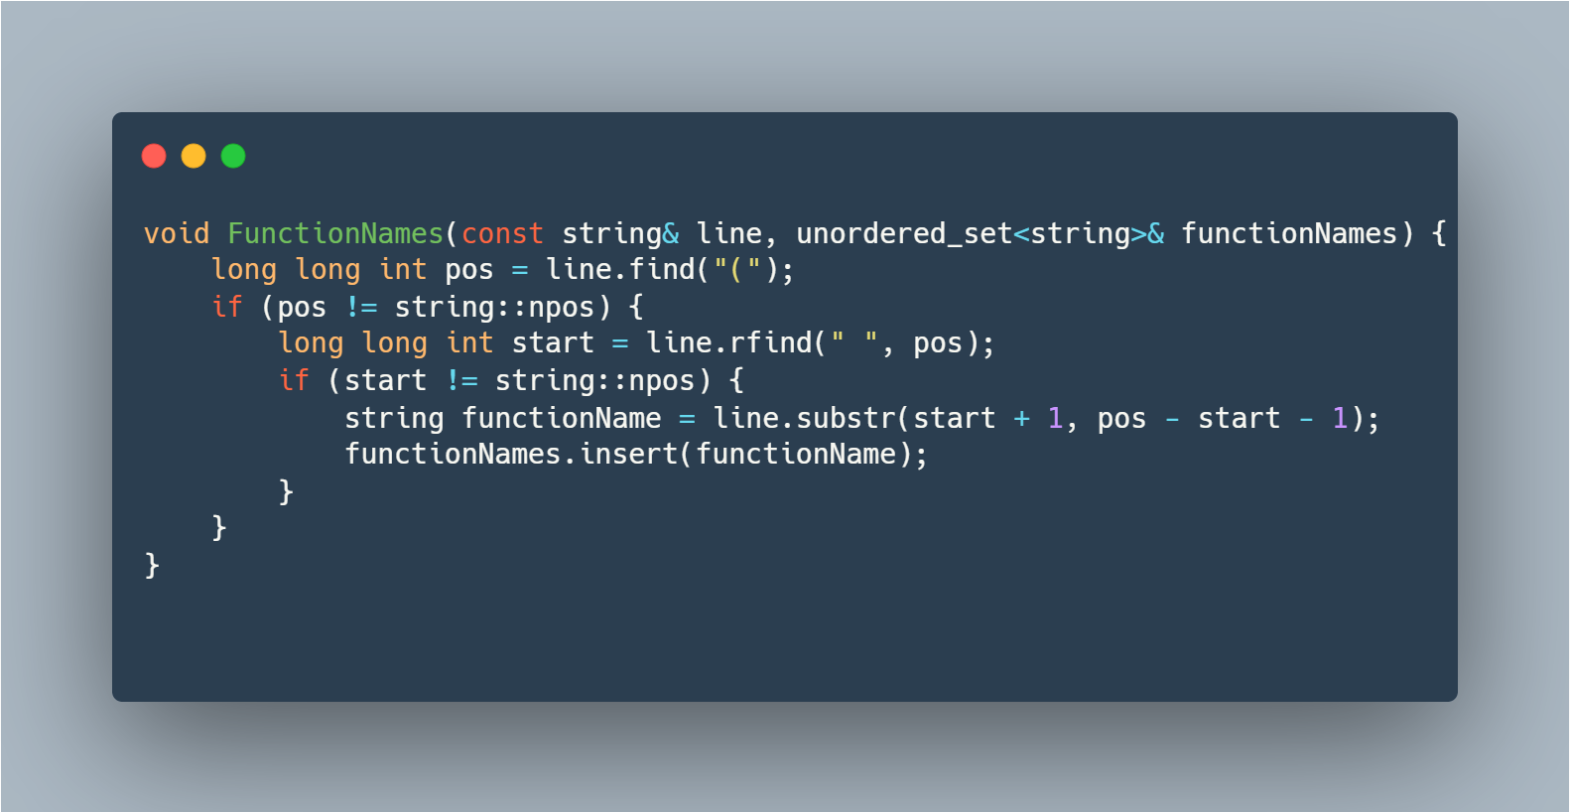
- Parameters:
  - const string& line: This parameter represents a line of code (presumably a C++ code line) from which we want to extract function names. The const qualifier indicates that the function will not modify the input line, and & signifies that the parameter is a reference to a string to avoid unnecessary copying.
  - unordered_set<string>& functionNames: This parameter is an unordered set of strings where the extracted function names will be stored. The use of a set ensures that each function name is unique.
- Variable Declarations:
  - long long int pos: This variable stores the position of the opening parenthesis '(' in the line. It is of type long long int to accommodate larger line positions.
  - long long int start: This variable stores the position of the last space character before the opening parenthesis. It helps identify the starting position of the function name.
  - string functionName: This variable will store the extracted function name.
- Finding the Opening Parenthesis:
  - pos = line.find("("): This line searches for the position of the opening parenthesis '(' in the input line. If the opening parenthesis is found, pos will store its position; otherwise, it will be set to string::npos (a constant representing "not found").
- Extracting the Function Name:
  - start = line.rfind(" ", pos): This line searches backward from the position of the opening parenthesis to find the last space character before it. This helps identify the starting position of the function name. If a space is found, start will store its position; otherwise, it will be set to string::npos.
  - string functionName = line.substr(start + 1, pos - start - 1): This line extracts the substring between the last space character and the opening parenthesis, representing the function name. It uses the substr function of the string class.
- Inserting into the Set:
  - functionNames.insert(functionName): This line inserts the extracted function name into the unordered set functionNames. Since sets store unique elements, this ensures that each function name is added only once.

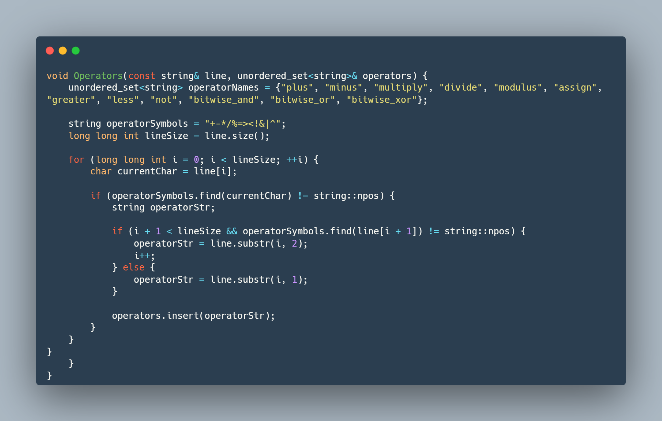

- Parameter:
  - const string& line: This parameter represents a line of code (presumably a C++ code line) from which we want to extract operators. The const qualifier indicates that the function will not modify the input line, and & signifies that the parameter is a reference to a string to avoid unnecessary copying.
  - unordered_set<string>& operators: This parameter is an unordered set of strings where the extracted operators will be stored. The use of a set ensures that each operator is unique.
- Operator Names Set:
  - unordered_set<string> operatorNames = {"plus", "minus", "multiply", "divide", "modulus", "assign", "greater", "less", "not", "bitwise_and", "bitwise_or", "bitwise_xor"};: This line initializes an unordered set operatorNames with the names corresponding to each operator symbol. This set is used to print the names of operators later in the main program.
- Operator Symbols String:
  - string operatorSymbols = "+-*/%=><!&|^";: This line defines a string operatorSymbols containing the symbols of operators that the function will search for in the input line.
- Looping Through the Line:
  - for (long long int i = 0; i < lineSize; ++i) {: This line starts a loop that iterates through each character in the input line.
  - char currentChar = line[i];: Inside the loop, the variable currentChar is assigned the current character being processed in the line.
- Identifying Operators:
  - if (operatorSymbols.find(currentChar) != string::npos) {: This condition checks if the current character is one of the operator symbols defined in operatorSymbols.
  - string operatorStr;: This line declares a string operatorStr to store the extracted operator.
  - if (i + 1 < lineSize && operatorSymbols.find(line[i + 1]) != string::npos) {: This condition checks if the next character is also an operator. If true, it considers the current character and the next character together.
  - operatorStr = line.substr(i, 2);: If the next character is an operator, it extracts a substring of length 2 (both characters) starting from the current position i.
  - i++;: The loop variable i is incremented to skip the next character since it has already been considered.
  - else { operatorStr = line.substr(i, 1); }: If the next character is not an operator, it extracts a substring of length 1 (only the current character).
  - operators.insert(operatorStr);: The extracted operator (either one character or two) is inserted into the unordered set operators.
CODE:

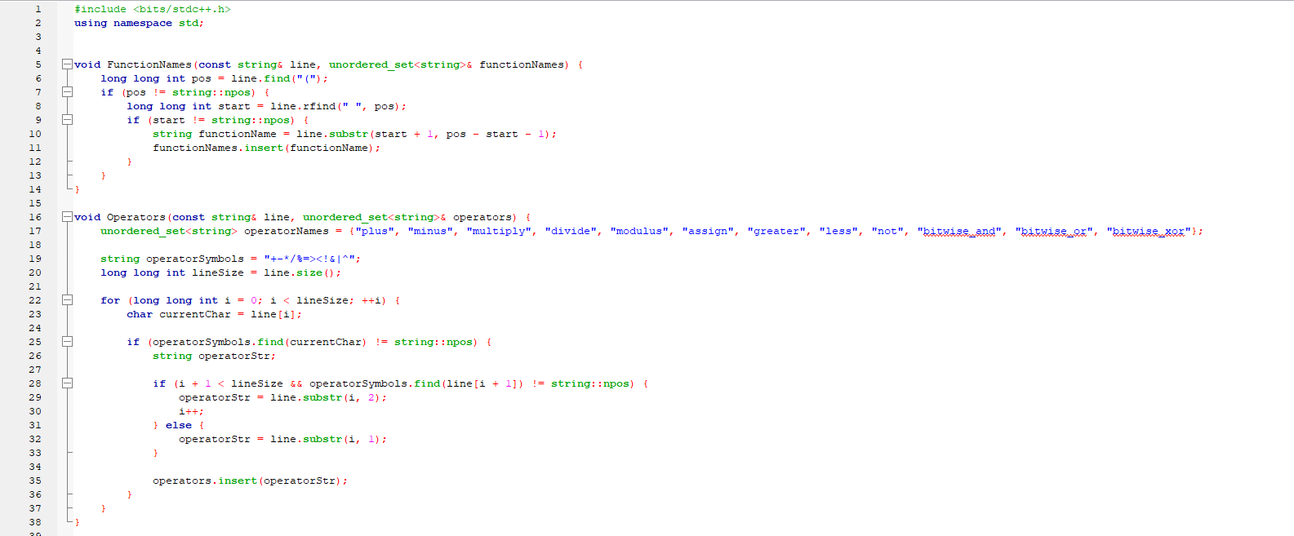

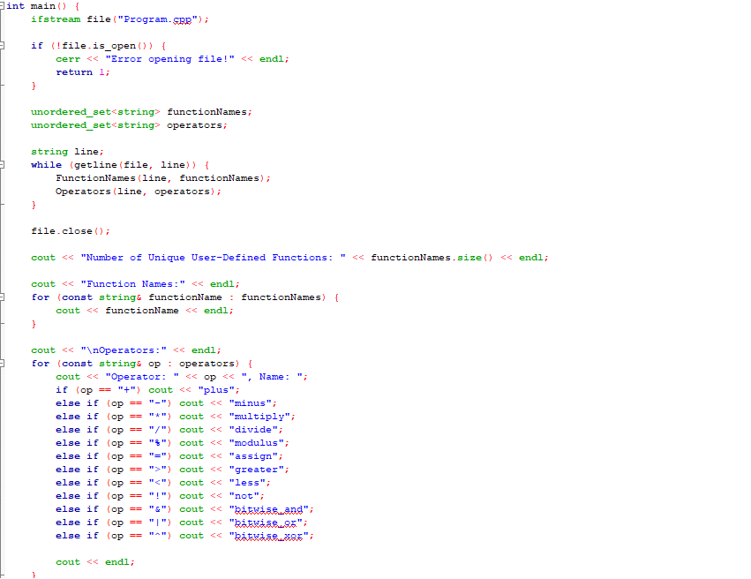

OUTPUT SCREEN-SHOT:

